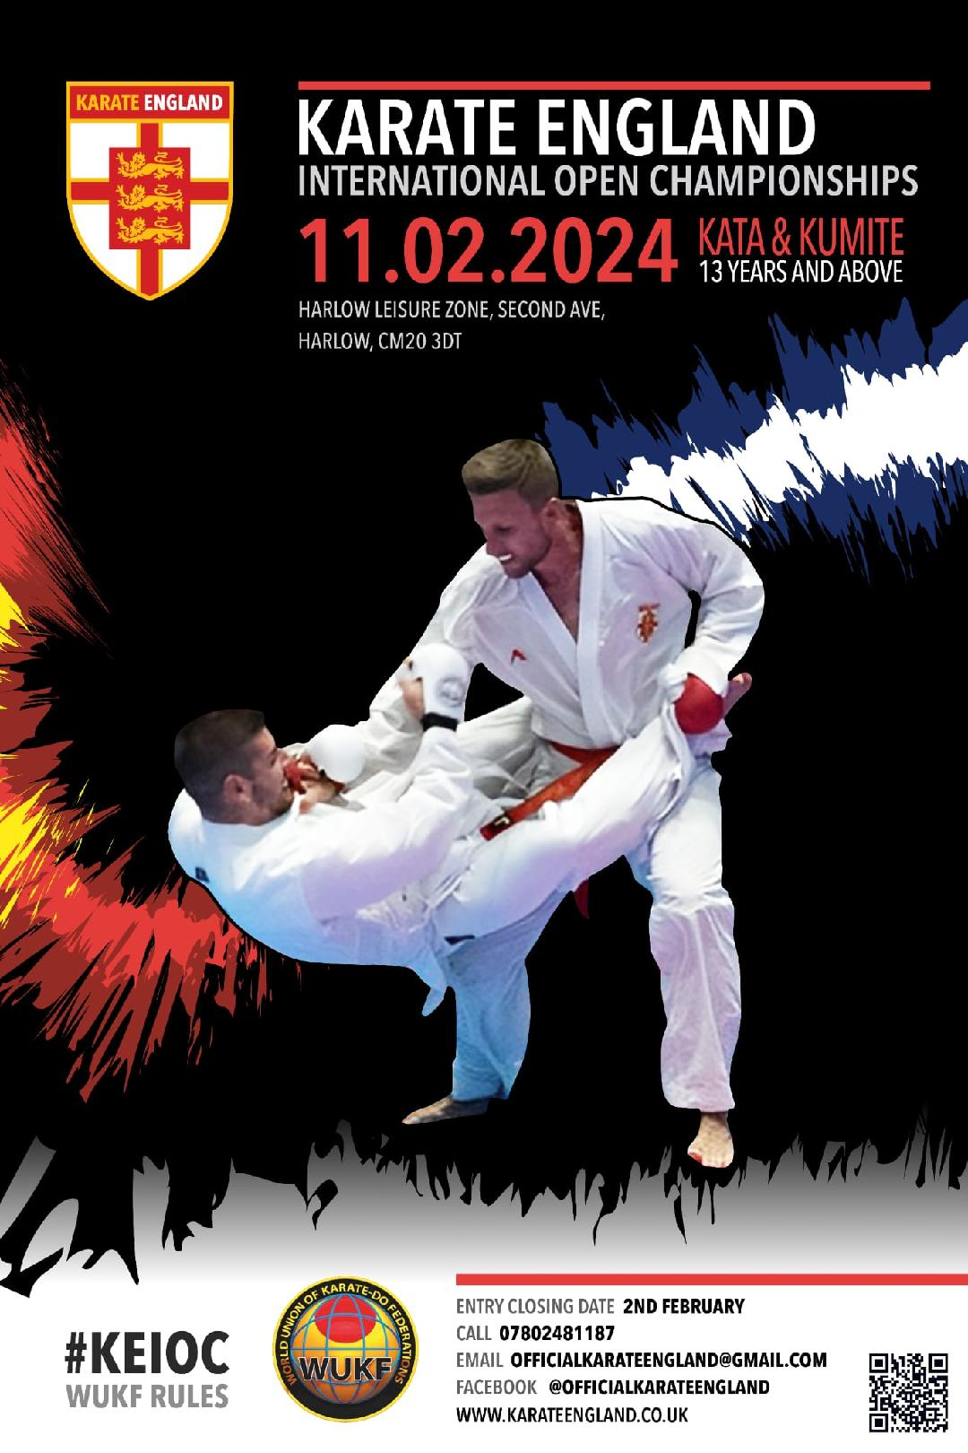

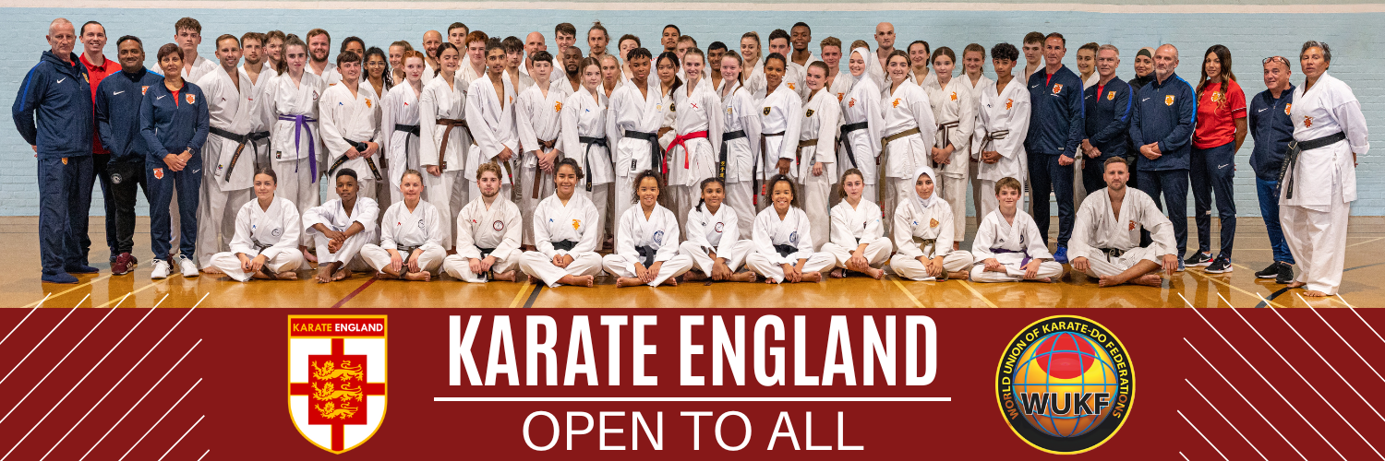

2024 KARATE ENGLAND
INTERNATIONAL OPEN CHAMPIONSHIPS

SUNDAY FEBRUARY 11TH 2024

Harlow Leisure Zone, Second Ave, Harlow, CM20 3DT

Dear Colleagues,

On behalf of the Karate England Board, I would like to invite you all to the 2024 Karate England International Open Championships to be held at the Harlow Leisure Zone, Second Ave, Harlow CM20 3DT, on Sunday 11th February 2024.

This competition will be for Karate-ka’s that are 13 years old and above only and we will be run on one day with an entry cap.. Our aim as always is to create a smooth running event, finishing at a reasonable time with quality Karate.

These championships are truly open to all club/association teams and individuals of all bona fide karate associations regardless of their current affiliation. It is also an opportunity for us all to put aside any political differences and renew our rivalries and our friendships in the true spirit of karate-do.

Coaches are reminded of their responsibility and the importance of insurance cover for all competitors. By signing entry forms coaches will be confirming they have seen all current registration / licence slips which include insurance cover for the named competitors.

Coaches and competitors are reminded that they must be in the correct weight category as no changes can be accepted on the day.

All entries and payment must be in by the closing date of 4th February 2024, or before the entry cap has been reached.

Please note payment methods must be agreed with the written consent of event organisers and must be received with entries by the closing date of 4th Feb. All cheques must be made out to "KarateSport England" and cleared before the date of the championships and sent to event organisers: c/o 41 Millfield, High Ongar, Essex CM5 9RJ

Bank transfers can be made to:- Name: Karate Sport England
Sort Code: 51-61-35 | Account Number: 75181959
Please use your entry name as reference and advise organisers that payment has been made.

This is vital in order that we can provide you in advance a practical running order. We look forward to seeing you all in Harlow and look forward to an enjoyable day.

Yours truly,
Karate England Event Organising Committee

Sunday 11th February 2024:
8.30 am : Registration, Referee & Coaches meeting.
9.00 am : Kata
11.30am: Some kumite will begin
A more accurate schedule and running order will be sent to you nearer the time.

All competitors should be in the main arena 30 minutes before the time of their scheduled event. The weigh-in is open throughout the day. It is the coaches’ and competitors’ responsibility to be in good time for the weigh–in and licence check for their category before their event starts.

This has been organised so that we can remove competitors who fail the weigh-in.

A RUNNING ORDER WILL BE PROVIDED BEFORE THE EVENT DATE.

WUKF Referee Commissioner Mr Pete Priest will be the Chief Referee for the 2024 Karate England International Open Championships.

Rules will be WUKF with the possibility of some small alterations by the organisers that will be announced on the day at 8.30 am to all referee's and coach's present.

Kata:

All Associations are requested to send licensed referees (Association, National Governing Body, WUKF) for Kata and/or Kumite. Please provide names in advance to the Karate England Referee Commission: officialkarateengland@gmail.com

Protective Equipment
- Approved Red and White mitts are mandatory for all Kumite.
- Chest Protectors are compulsory for all female competitors
- Shin pads, foot pads and groin guards are optional in Sanbon Kumite.
- Competitors must provide their own Red & White belts.
- Gumshields are mandatory in Sanbon Kumite.

This event is OPEN to all individuals and clubs/groups/association or federations teams. All individual categories must have a minimum of 8 participants or they will be amalgamated where possible or cancelled. All team categories must have a minimum of 4 participating teams or they will be amalgamated where possible or cancelled. Kata competitors may enter one style section and an open section. Kumite competitors may enter their Sanbon weight section and Ippon open.

Individual Entry Fees: £20 per category
Team Entry Fees: £30 per category (kata or kumite)
Spectator Fees: Adults £10, Children £5 (Under 12 years Free)

CATEGORY LIST

No. | Category | Gender | Age | Grade
001 | Mini Cadet Shotokan Kata | Male | 13 y/o | Open
002 | Mini Cadet Wado-Ryu Kata | Male | 13 y/o | Open
003 | Mini Cadet Shito-Ryu Kata | Male | 13 y/o | Open
004 | Mini Cadet Goju-Ryu Kata | Male | 13 y/o | Open
005 | Mini Cadet Other Styles Kata | Male | 13 y/o | Open
006 | Mini Cadet Open Kata | Male | 13 y/o | Open
007 | Mini Cadet Shotokan Kata | Female | 13 y/o | Open
008 | Mini Cadet Wado-Ryu Kata | Female | 13 y/o | Open
009 | Mini Cadet Shito-Ryu Kata | Female | 13 y/o | Open
010 | Mini Cadet Goju-Ryu Kata | Female | 13 y/o | Open
011 | Mini Cadet Other Styles Kata | Female | 13 y/o | Open
012 | Mini Cadet Open Kata | Female | 13 y/o | Open
013 | Cadet B Shotokan Kata | Male | 14-15 y/o | Open
014 | Cadet B Wado-Ryu Kata | Male | 14-15 y/o | Open
015 | Cadet B Shito-Ryu Kata | Male | 14-15 y/o | Open
016 | Cadet B Goju-Ryu Kata | Male | 14-15 y/o | Open
017 | Cadet B Other Styles Kata | Male | 14-15 y/o | Open
018 | Cadet B Open Kata | Male | 14-15 y/o | Open
019 | Cadet B Shotokan Kata | Female | 14-15 y/o | Open
020 | Cadet B Wado-Ryu Kata | Female | 14-15 y/o | Open
021 | Cadet B Shito-Ryu Kata | Female | 14-15 y/o | Open
022 | Cadet B Goju-Ryu Kata | Female | 14-15 y/o | Open
023 | Cadet B Other Styles Kata | Female | 14-15 y/o | Open
024 | Cadet B Open Kata | Female | 14-15 y/o | Open
025 | Cadet A Shotokan Kata | Male | 16-17 y/o | Open
026 | Cadet A Wado-Ryu Kata | Male | 16-17 y/o | Open
027 | Cadet A Shito-Ryu Kata | Male | 16-17 y/o | Open
028 | Cadet A Goju-Ryu Kata | Male | 16-17 y/o | Open
029 | Cadet A Other Styles Kata | Male | 16-17 y/o | Open
030 | Cadet A Open Kata | Male | 16-17 y/o | Open
031 | Cadet A Shotokan Kata | Female | 16-17 y/o | Open
032 | Cadet A Wado-Ryu Kata | Female | 16-17 y/o | Open
033 | Cadet A Shito-Ryu Kata | Female | 16-17 y/o | Open
034 | Cadet A Goju-Ryu Kata | Female | 16-17 y/o | Open
035 | Cadet A Other Styles Kata | Female | 16-17 y/o | Open
036 | Cadet A Open Kata | Female | 16-17 y/o | Open
037 | Cadet Inclusive Open Kata | Mixed | 13-17 y/o | Open
038 | Junior Shotokan Kata | Male | 18-20 y/o | Open
039 | Junior Wado-Ryu Kata | Male | 18-20 y/o | Open
040 | Junior Shito-Ryu Kata | Male | 18-20 y/o | Open
041 | Junior Goju-Ryu Kata | Male | 18-20 y/o | Open
042 | Junior Other Styles Kata | Male | 18-20 y/o | Open
043 | Junior Open Kata | Male | 18-20 y/o | Open
044 | Junior Shotokan Kata | Female | 18-20 y/o | Open
045 | Junior Wado-Ryu Kata | Female | 18-20 y/o | Open
046 | Junior Shito-Ryu Kata | Female | 18-20 y/o | Open
047 | Junior Goju-Ryu Kata | Female | 18-20 y/o | Open
048 | Junior Other Styles Kata | Female | 18-20 y/o | Open
049 | Junior Open Kata | Female | 18-20 y/o | Open
050 | Senior Shotokan Kata | Male | 21-35 y/o | Open
051 | Senior Wado-Ryu Kata | Male | 21-35 y/o | Open
052 | Senior Shito-Ryu Kata | Male | 21-35 y/o | Open
053 | Senior Goju-Ryu Kata | Male | 21-35 y/o | Open
054 | Senior Other Styles Kata | Male | 21-35 y/o | Open
055 | Senior Open Kata | Male | 21-35 y/o | Open
056 | Senior Shotokan Kata | Female | 21-35 y/o | Open
057 | Senior Wado-Ryu Kata | Female | 21-35 y/o | Open
058 | Senior Shito-Ryu Kata | Female | 21-35 y/o | Open
059 | Senior Goju-Ryu Kata | Female | 21-35 y/o | Open
060 | Senior Other Styles Kata | Female | 21-35 y/o | Open
061 | Senior Open Kata | Female | 21-35 y/o | Open
062 | Senior Inclusive Open Kata | Mixed | 18-35 y/o | Open
063 | Veteran Open Kata | Male | 36+ y/o | Open
064 | Veteran Open Kata | Female | 36+ y/o | Open
065 | Veteran Inclusive Open Kata | Mixed | 36+ y/o | Open
066 | Mini Cadet Open Team Kata | Male | 13 y/o | Open
067 | Mini Cadet Open Team Kata | Female | 13 y/o | Open
068 | Cadet B Open Team Kata | Male | 14-15 y/o | Open
069 | Cadet B Open Team Kata | Female | 14-15 y/o | Open
070 | Cadet A Open Team Kata | Male | 16-17 y/o | Open
071 | Cadet A Open Team Kata | Female | 16-17 y/o | Open
072 | Junior Open Team Kata | Male | 18-20 y/o | Open
073 | Junior Open Team Kata | Female | 18-20 y/o | Open
074 | Senior Open Team Kata | Male | 21-35 y/o | Open
075 | Senior Open Team Kata | Female | 21-35 y/o | Open
076 | Veteran Open Team Kata | Male | 36+ y/o | Open
077 | Veteran Open Team Kata | Female | 36+ y/o | Open

No. | Category | Gender | Age | Weight
078 | Mini Cadet Sanbon Kumite | Male | 13 y/o | -45kg
079 | Mini Cadet Sanbon Kumite | Male | 13 y/o | -55kg
080 | Mini Cadet Sanbon Kumite | Male | 13 y/o | -65kg
081 | Mini Cadet Sanbon Kumite | Male | 13 y/o | +65kg
082 | Mini Cadet Sanbon Kumite | Female | 13 y/o | -50kg
083 | Mini Cadet Sanbon Kumite | Female | 13 y/o | -55kg
084 | Mini Cadet Sanbon Kumite | Female | 13 y/o | -60kg
085 | Mini Cadet Sanbon Kumite | Female | 13 y/o | +60kg
086 | Mini Cadet Ippon Kumite | Male | 13 y/o | Open
087 | Mini Cadet Ippon Kumite | Female | 13 y/o | Open
088 | Cadet B Sanbon Kumite | Male | 14-15 y/o | -55kg
089 | Cadet B Sanbon Kumite | Male | 14-15 y/o | -65kg
090 | Cadet B Sanbon Kumite | Male | 14-15 y/o | -75kg
091 | Cadet B Sanbon Kumite | Male | 14-15 y/o | +75kg
092 | Cadet B Sanbon Kumite | Female | 14-15 y/o | -50kg
093 | Cadet B Sanbon Kumite | Female | 14-15 y/o | -55kg
094 | Cadet B Sanbon Kumite | Female | 14-15 y/o | -60kg
095 | Cadet B Sanbon Kumite | Female | 14-15 y/o | -65kg
096 | Cadet B Ippon Kumite | Male | 14-15 y/o | Open
097 | Cadet B Ippon Kumite | Female | 14-15 y/o | Open
098 | Cadet A Sanbon Kumite | Male | 16-17 y/o | -55kg
099 | Cadet A Sanbon Kumite | Male | 16-17 y/o | -65kg
100 | Cadet A Sanbon Kumite | Male | 16-17 y/o | -75kg
101 | Cadet A Sanbon Kumite | Male | 16-17 y/o | +75kg
102 | Cadet A Sanbon Kumite | Female | 16-17 y/o | -50kg
103 | Cadet A Sanbon Kumite | Female | 16-17 y/o | -55kg
104 | Cadet A Sanbon Kumite | Female | 16-17 y/o | -60kg
105 | Cadet A Sanbon Kumite | Female | 16-17 y/o | +60kg
106 | Cadet A Ippon Kumite | Male | 16-17 y/o | Open
107 | Cadet A Ippon Kumite | Female | 16-17 y/o | Open
108 | Cadet Inclusive Combat Kodo | Mixed | 13-17 y/o | Open
109 | Junior Sanbon Kumite | Male | 18-20 y/o | -65kg
110 | Junior Sanbon Kumite | Male | 18-20 y/o | -75kg
111 | Junior Sanbon Kumite | Male | 18-20 y/o | -85kg
112 | Junior Sanbon Kumite | Male | 18-20 y/o | +85kg
113 | Junior Sanbon Kumite | Female | 18-20 y/o | -55kg
114 | Junior Sanbon Kumite | Female | 18-20 y/o | -60kg
115 | Junior Sanbon Kumite | Female | 18-20 y/o | -65kg
116 | Junior Sanbon Kumite | Female | 18-20 y/o | +65kg
117 | Junior Ippon Kumite | Male | 18-20 y/o | Open
118 | Junior Ippon Kumite | Female | 18-20 y/o | Open
119 | Senior Sanbon Kumite | Male | 21-35 y/o | -65kg
120 | Senior Sanbon Kumite | Male | 21-35 y/o | -75kg
121 | Senior Sanbon Kumite | Male | 21-35 y/o | -85kg
122 | Senior Sanbon Kumite | Male | 21-35 y/o | +85kg
123 | Senior Sanbon Kumite | Female | 21-35 y/o | -55kg
124 | Senior Sanbon Kumite | Female | 21-35 y/o | -60kg
125 | Senior Sanbon Kumite | Female | 21-35 y/o | -65kg
126 | Senior Sanbon Kumite | Female | 21-35 y/o | +65kg
127 | Senior Ippon Kumite | Male | 21-35 y/o | Open
128 | Senior Ippon Kumite | Female | 21-35 y/o | Open
129 | Senior Inclusive Combat Kodo | Mixed | 18-35 y/o | Open
130 | Veteran Sanbon Kumite | Male | 36+ y/o | -75kg
131 | Veteran Sanbon Kumite | Male | 36+ y/o | +75kg
132 | Veteran Sanbon Kumite | Female | 36+ y/o | -60kg
133 | Veteran Sanbon Kumite | Female | 36+ y/o | +60kg
134 | Veteran Ippon Kumite | Male | 36+ y/o | Open
135 | Veteran Ippon Kumite | Female | 36+ y/o | Open
136 | Veteran Inclusive Combat Kodo | Mixed | 36+ y/o | Open
137 | Mini Cadet Sanbon Team Rotation Kumite | Male | 13 y/o | Open
138 | Mini Cadet Sanbon Team Rotation Kumite | Female | 13 y/o | Open
139 | Cadet B Sanbon Team Rotation Kumite | Male | 14-15 y/o | Open
140 | Cadet B Sanbon Team Rotation Kumite | Female | 14-15 y/o | Open
141 | Cadet A Sanbon Team Rotation Kumite | Male | 16-17 y/o | Open
142 | Cadet A Sanbon Team Rotation Kumite | Female | 16-17 y/o | Open
143 | Junior Sanbon Team Rotation Kumite | Male | 18-20 y/o | Open
144 | Junior Sanbon Team Rotation Kumite | Female | 18-20 y/o | Open
145 | Senior Sanbon Team Rotation Kumite | Male | 21-35 y/o | Open
146 | Senior Sanbon Team Rotation Kumite | Female | 21-35 y/o | Open
147 | Veteran Sanbon Team Rotation Kumite | Male | 36+ y/o | Open
148 | Veteran Sanbon Team Rotation Kumite | Female | 36+ y/o | Open

Coaches
On entering athletes for this event we require the following:

- Athletes Name
- Gender
- Age on day of event
- Weight where relevant
- Category number/s
As well as a list of coaches and referee names. Please send the required information to cuthbertshikon@aol.com no later than 4th February 2024.

Please note that categories will be cancelled or amalgamated should there be less than 4 competitiors.

WUKF rules and kata lists can be found here:
wukf-karate.org/rules

.

